**IBM SPSS Statistics Project**

*By Mei Chiao Lin, Sep 27th 2019*

1. Variable:

Income: Household income in thousands

Reside: Number of people in household

Carcat: Primary vehicle price category

1. Summary with chart
2. Income increase by carcat. That’s reasonable that people are willing to purchase more expansive car with higher income. The car prices increase from economic to standard to luxury.
3. No obvious trend of reside by carcat. That means when people purchase cars doesn’t base on how many people in household.
4. Income decrease as reside increase. While carcat doesn’t change obviously. That means **average** income will decease while people in the household is increase. Usually, the most income source in a household comes from one to two people, such as father, mother. Usually the kids, youth and elder earn less income or don’t have income.
5. No obvious trend of carcat by reside
6. Group bar chart with separate variables of income and reside by carcat

* The **income** **increase** when carcat from Economy (income ~ 21.89K) to Standard (income ~ 42.56K) and Luxury (income ~ 134.64K). However, the reside doesn’t show obvious trend by carcat, around 2 people per household. As the following bar chart shows.

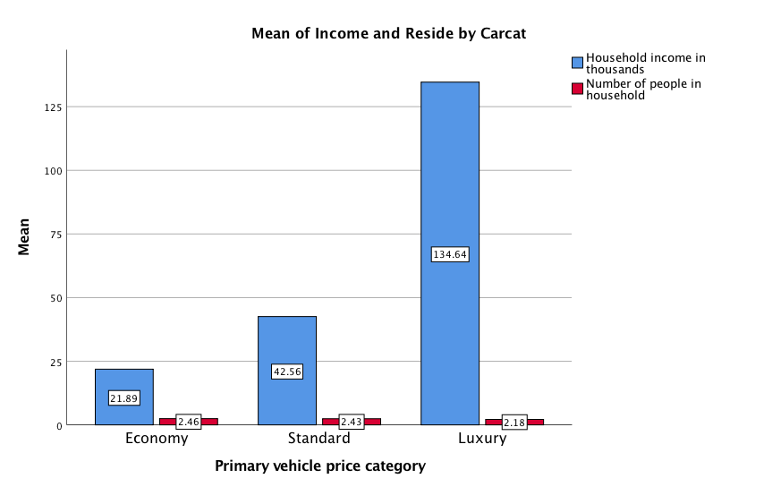

1. A group errorbar chart of income and reside by carcat shows that income increase quadratic, but reside doesn’t have obvious change.

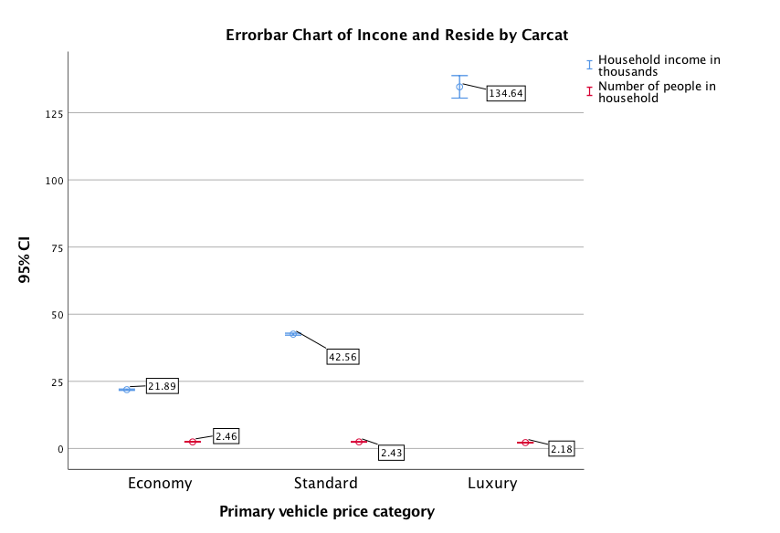

1. A errorbar chart of income and carcat by reside shows that the income decreases as the reside increases. While the carcat doesn’t have obvious change as reside increases.

